|  |  |
| --- | --- |
|  | **DEPARTMENT OF COMPUTER ENGINEERING** |

**Case Study No. 01**

|  |  |
| --- | --- |
| Semester | B.E. Semester VII – Computer Engineering |
| Subject | Data Science |
| Subject Professor In-charge | Prof. Neha Kudu |
| Academic Year | 2024-25 |

|  |  |
| --- | --- |
| Student Name | Deep Salunkhe |
| Roll Number | 21102A0014 |
| Topic | The Impact and Ethical Implications of Electronic Health Record |

**1. Background Research on Electronic Health Records (EHRs)**

**Brief History:**

The evolution of EHRs is closely tied to advances in technology and the growing complexity of healthcare systems. The need for digitizing medical records stemmed from the inefficiencies and limitations of paper-based systems, which were prone to human errors, difficult to share across different healthcare providers, and expensive to store and maintain.

In the case of Cleveland Clinic, early digitization efforts began in the 1990s with specific systems for managing billing and patient scheduling. However, these systems were isolated and did not provide a unified view of patient information. This siloed approach created a disconnect between departments, causing delays in treatment, errors in medication prescriptions, and administrative inefficiencies.

By the early 2000s, advances in computing power and storage capabilities enabled more comprehensive systems to emerge. Cleveland Clinic began exploring Electronic Medical Records (EMRs) for patient health data, but these systems primarily focused on internal documentation without the integration capabilities of modern EHRs. The real turning point came when the U.S. government enacted the **Health Information Technology for Economic and Clinical Health (HITECH) Act** in 2009, providing financial incentives to healthcare providers that adopted certified EHR technology. Cleveland Clinic responded to this by fully implementing an integrated EHR system in 2010, driven by both the need for operational efficiency and the financial advantages provided by the HITECH Act.

**Key Milestones:**

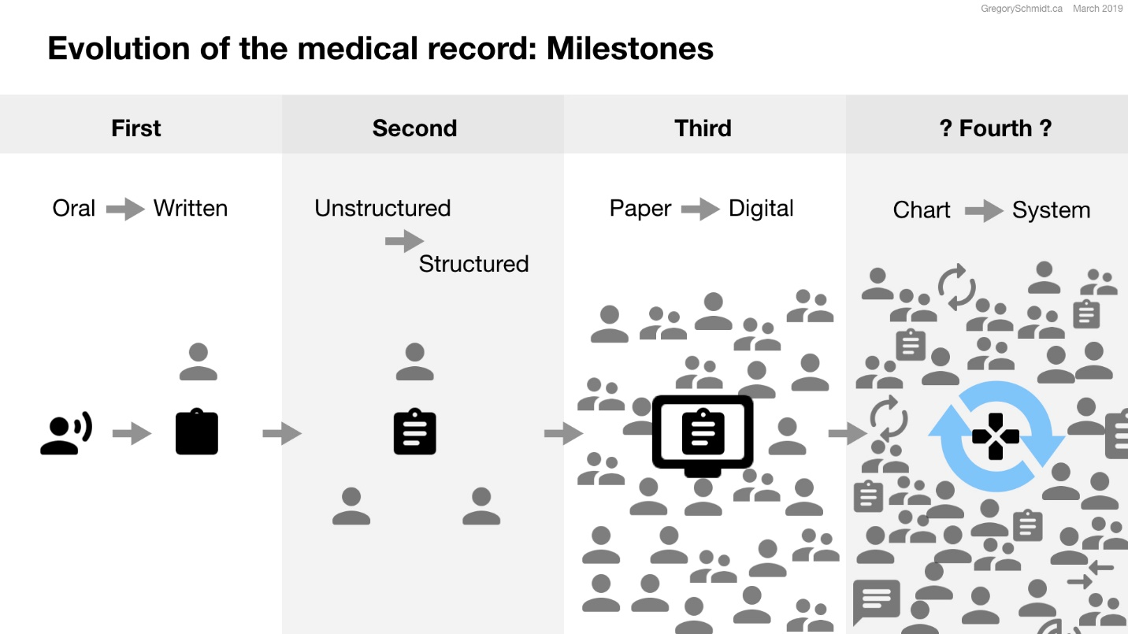

**ff**

One of the most significant milestones in Cleveland Clinic’s EHR journey was its decision to adopt **Epic**, a leading EHR platform, in 2010. Epic was chosen for its scalability, flexibility, and ability to integrate various aspects of patient care, from medical history to billing and insurance. The full-scale implementation took several years, requiring significant financial and human resources. Training staff, digitizing existing patient records, and configuring the system to meet Cleveland Clinic’s specific needs were all part of the process.

Globally, similar movements towards digitization occurred, with countries like the United Kingdom launching the **National Programme for IT (NPfIT)** in 2002 to create electronic records for all patients. In Canada, the **Canada Health Infoway** was established in 2001 to accelerate the development and adoption of EHR systems across the nation.

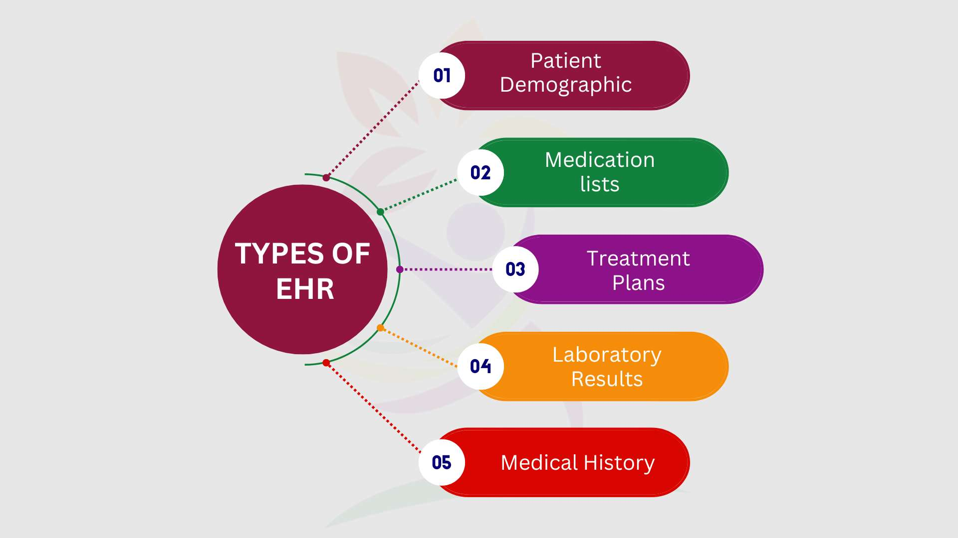

**Types of EHR Systems:**

* **On-Premise vs. Cloud-Based**: Initially, Cleveland Clinic adopted an on-premise solution where data was stored and managed in-house. This required significant investment in hardware and IT infrastructure. However, as cloud technology became more secure and reliable, Cleveland Clinic transitioned to a **cloud-based EHR system**, allowing for more flexibility and reducing the burden of maintaining local servers. Cloud-based EHRs also made it easier for multiple clinic locations to access patient data seamlessly.
* **Specialized EHRs**: Cleveland Clinic's EHR system is tailored specifically for a multi-specialty hospital environment. Unlike EHRs designed for general practitioners, the Epic system supports complex operations such as surgical documentation, oncology treatment tracking, and pediatric care management.
* **Customizable EHRs vs. Pre-Configured Systems**: Cleveland Clinic opted for a highly customizable version of Epic. While this increased the initial complexity and cost of implementation, it allowed for specific configurations suited to their workflows. For example, Epic’s customizable modules were adapted to integrate with Cleveland Clinic’s existing laboratory systems, radiology departments, and patient scheduling software.

**EHR Functionality:**

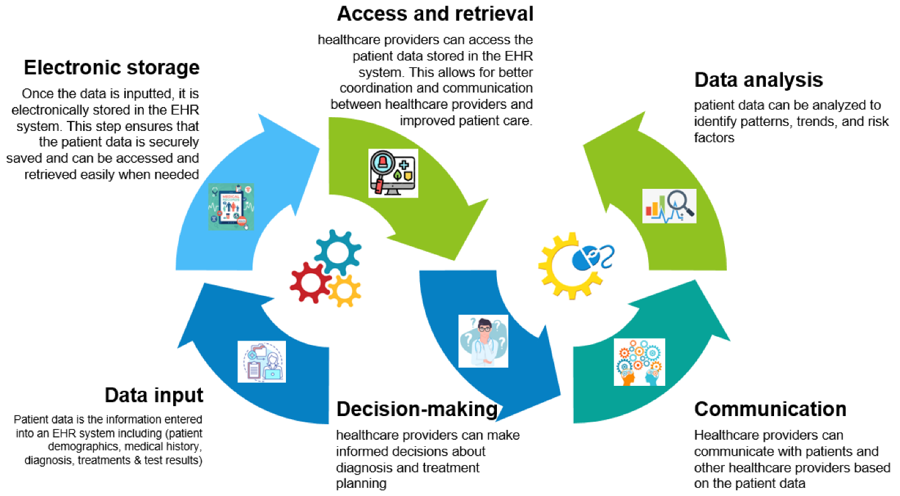

* **Digital Health Records**: Cleveland Clinic's EHR stores comprehensive data, including patient medical history, diagnostic results, medications, allergies, and immunization records. The system also tracks patient visits and surgeries, providing a complete, centralized record of a patient's interactions with the healthcare system.
* **Integration with Other Systems**: One of the most powerful features of Cleveland Clinic's EHR is its ability to integrate with external systems. For example, the EHR system is connected to external laboratories for automated test result uploads. It also interfaces with local pharmacies to streamline prescription management and with external radiology systems for the transfer of imaging data.
* **e-Prescribing and Decision Support**: The EHR's electronic prescribing (eRx) module allows physicians to prescribe medications digitally, reducing prescription errors. Additionally, the decision support system in Epic flags potential drug interactions, alerts doctors to allergies, and suggests optimal treatment pathways based on clinical guidelines.

**Comparison with Traditional Paper Records:**

* **Efficiency**: Before adopting EHRs, Cleveland Clinic struggled with the inefficiencies of paper records. Paper charts were often misplaced, incomplete, or delayed in reaching other departments. By digitizing records, the clinic greatly improved the speed of record access. Physicians can now retrieve a patient's complete medical history within seconds, allowing for quicker and more informed decision-making.
* **Accessibility**: With paper records, healthcare providers at Cleveland Clinic could only access patient data from the location where the records were stored. This posed significant challenges for specialists or providers located at different facilities. EHRs, on the other hand, offer **multi-location access**. Physicians in different clinics or even during home visits can now securely access patient information in real time.
* **Cost**: While the initial cost of EHR implementation at Cleveland Clinic was substantial, involving investments in software, hardware, and staff training, the long-term operational costs decreased. EHRs significantly reduced the need for paper, storage space, and clerical personnel. Moreover, with the **HITECH Act** providing financial incentives, Cleveland Clinic was able to recover part of its investment, making the transition more financially viable.

**2. Impact on Healthcare Delivery**

**Efficiency:**

* **Time Savings**: Before EHRs, the time spent searching for paper records was considerable. If a patient had multiple appointments or needed a specialist’s consultation, their paper records had to be physically transferred from one department to another, sometimes causing delays in care. With the EHR system, a patient’s entire medical history is available immediately. For example, at Cleveland Clinic, a surgeon can access a patient’s complete health record, including past surgeries, medication history, and allergies, in just a few clicks. This streamlining allows healthcare providers to make faster, more informed decisions, ultimately speeding up the diagnosis and treatment process.
* **Automated Reminders**: Cleveland Clinic’s EHR system includes automated reminders that prompt healthcare providers to schedule preventive care measures, such as mammograms or colonoscopies, based on patient data. For instance, if a patient is due for a diabetes check-up or a routine vaccination, the EHR system flags it, prompting the physician to take action. This reduces the likelihood of missed appointments or delayed preventive care.
* **Reduction of Errors**: EHRs have been particularly effective in reducing medication errors. In the paper-record system, handwritten prescriptions were sometimes difficult to read, leading to potential errors in medication dosage or type. With EHRs, prescriptions are entered digitally and cross-checked against patient records for allergies and potential drug interactions. For example, at Cleveland Clinic, the EHR system prevents physicians from prescribing medications that could interact negatively with a patient's existing medications or medical conditions.

**Accessibility:**

* **Enhanced Provider Collaboration**: A key benefit of EHR systems is the ability to share information across providers and departments. Cleveland Clinic’s EHR allows for seamless collaboration between different specialties. For instance, when a patient with heart disease is referred to a neurologist, both the cardiologist and neurologist have access to the same health records. This improves care coordination, ensuring that all healthcare providers are working from the same set of information and preventing redundant tests or conflicting treatments.
* **Telemedicine Integration**: As the healthcare landscape shifts toward telemedicine, Cleveland Clinic has integrated its EHR system with telehealth platforms. During the COVID-19 pandemic, this allowed doctors to access patient records while conducting video consultations, ensuring that patients received consistent care even when they could not physically visit the clinic. For example, a patient recovering from surgery could have a follow-up consultation via video, with the physician accessing post-operative records in real time to evaluate their recovery.

**Communication:**

* **Inter-Provider Communication**: Cleveland Clinic’s EHR system allows primary care providers, specialists, and surgeons to communicate more effectively. The system flags important health updates and ensures that all providers involved in a patient’s care are notified of significant developments. For instance, if a patient’s lab results indicate a critical condition, the EHR system automatically alerts the relevant specialists, ensuring timely intervention.
* **Patient-Provider Interaction**: The patient portal feature of Cleveland Clinic’s EHR system, called **MyChart**, allows patients to view their own medical records, test results, and appointment schedules. It also enables them to message their healthcare providers with non-urgent questions or concerns. For example, a patient who receives a lab test result indicating high cholesterol can use the portal to schedule a follow-up appointment or ask their physician for advice on lifestyle changes.

**3. Impact on Patient Outcomes**

**Positive Outcomes:**

* **Reduced Errors**: One of the primary benefits of EHR systems is their ability to reduce medical errors. Cleveland Clinic has seen a marked decrease in medication errors due to its EHR’s decision support tools. For example, when a physician prescribes a new medication, the EHR system automatically checks for potential drug interactions with the patient's current medications. If a conflict is detected, the system alerts the physician, prompting them to reconsider or adjust the prescription. This automated system significantly reduces the risk of adverse drug reactions, improving patient safety.
* **Improved Patient Safety**: Cleveland Clinic’s EHR system tracks patient allergies, immunizations, and other critical health data. This feature ensures that healthcare providers have access to the most up-to-date information when making treatment decisions. For instance, a physician prescribing antibiotics can see whether the patient has a known allergy to a particular drug, preventing potentially life-threatening allergic reactions.

**Challenges and Considerations:**

* **Privacy Concerns**: While EHRs provide many benefits, they also raise concerns about data security and patient privacy. Cleveland Clinic has implemented stringent security measures, such as multi-factor authentication, to protect sensitive patient information. However, the potential for data breaches remains a significant concern, particularly as cyberattacks on healthcare institutions increase.